Error Correction Encoder & Decoder | Digital Design and Logical Synthesis for Electrical Computer Engineering  (36113611)  Course Project
Error Correction Encoder & Decoder | Digital High Level Design  Version 0.1

Revision Log
Rev | Change | Description | Reason for change | Done By | Date
0.1 | Initial document | First Design of Encoder Decoder |  | Refael Ben Maor  Tal Kapelnik | 2.12.2021
0.2
0.3

Table of Content
LISt of figures 4
List of tables 5
2. Blocks Functional Descriptions 6
2.1.1 << component/feature #1 name>> 6
2.1.2 << component/feature #2 name>> 7
2.1.3 << component/feature #3 name>> 7
2.1.4 << component/feature #4 name>> 7
3. Appendix 8
3.1 Terminology 8
3.2 References 8

LISt of figures
Figure 1: view of the block. 8

List of tables
Table 1: Block interface. 9

Blocks Functional Descriptions

Top Level – Encoder Decoder & Error Fixer
Functional Description:
This module is a slave to the CPU , which control it with the APB bus and the register files.
The CPU send encoder or decoder data to the Error correction Encoder & Decoder diagram block and it give back the data result, operation_done out put ‘1’ when he finish, and num_of_errors that tell if was between 0-2 errors.
The Top-Level Error correction Encoder & Decoder consist 4 modules:
1) Registor_selctor – save the information about the Error correction encoder& decoder and initial parameters and send the date to require modules and also the CPU if he want to read from the registers.
2) Encoder – Get the data from the Registers_selector and the Top to encode the wanted data, also this module is use for the decoder part to save a space in the design the decoder part using the same components as the decoder.
3) Num_of_errors – Get data from the Top and the encoder to tell us how much errors we have in the wanted data , this data we sending out with num_of_errors and sending it to the next module Error_fixing .
4) Error_fixing – Get data from the Top and the Num_of_errors to fix the error in the data if he can, only when we have 1 error we fixing the data at the bit spot that need the correction.
<<This section should state the functional description of each element in the design. This will include: (1) input-process-output of each block (stated in detail in sub-sections under Section 2 herein), (2) signal/interface definitions (entities/architectures, functions, procedures, components, etc., (3) model hierarchy and diagram of what you’ve implemented (attach the details as a figure, if possible). Any key algorithms and data structures—such as for the FIFO blocks—should be described in this section as well. >>3
Top State Machine:
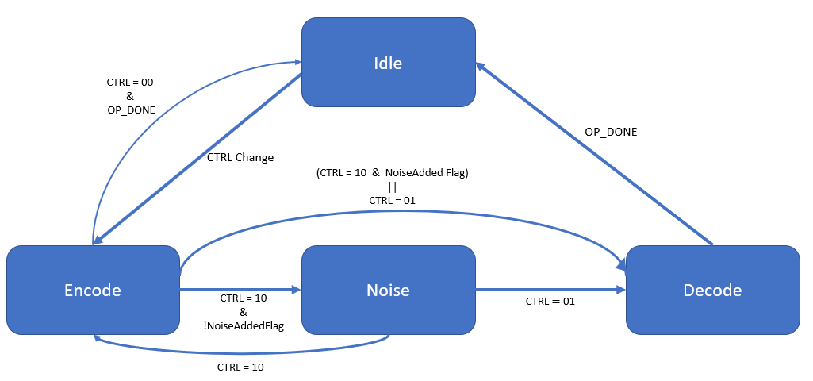

Interface
<<Edit the titles of these subsections with your specific names>>
Example: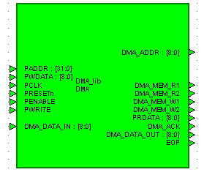>>
- view of the block.
Example:
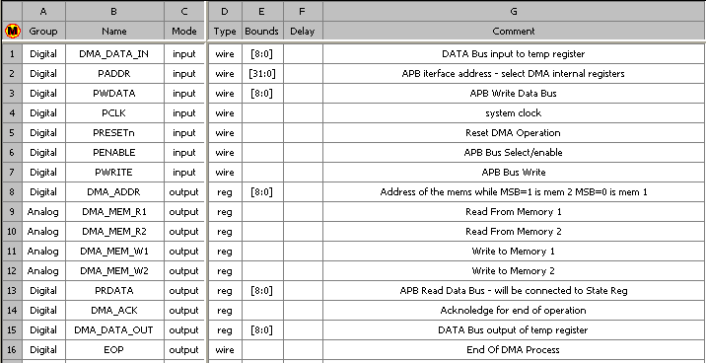
- Block interface.

Block Diagram
<< Simply copy/paste the Heading 2 line and rename it if you need more subsections that what is here. >>

<< component/feature #3 name>>
<< Delete the Heading 2 lines you don’t need. >>

<< component/feature #4 name>>
<< For any figures, number them sequentially, and copy/paste them into the document. Use Hdl Designer OLE drag and drop for drawing diagrams instead of Word’s drawing tools.. >>

Register Selector
Functional Description:
This module has the registers files that contains all the data for the Top-Level to work, all the registers get the data from the CPU via the APB bus . The Error correction Encoder & Decoder module can only read from this module with the wires DATA_IN_REG, CTRL_REG, CODEWORD_WIDTH_REG, NOISE_REG, PRDATA_REG when the PRDATA_REG is used to send data from the registers to the CPU when he ask for it.

Interface
<<Edit the titles of these subsections with your specific names>>
Example:>>
- view of the block.
Example:
- Block interface.

Block Diagram
<< Simply copy/paste the Heading 2 line and rename it if you need more subsections that what is here. >>

Flow Chart
<< Delete the Heading 2 lines you don’t need. >>

<< component/feature #4 name>>
<< For any figures, number them sequentially, and copy/paste them into the document. Use Hdl Designer OLE drag and drop for drawing diagrams instead of Word’s drawing tools.. >>

Num_of_Errors
Functional Description:
This module is a slave to the CPU , which control it with the APB bus and the register files.
The CPU send encoder or decoder data to the Error correction Encoder & Decoder diagram block and it give back the data result, operation_done out put ‘1’ when he finish, and num_of_errors that tell if was between 0-2 errors.
The Top-Level Error correction Encoder & Decoder consist 4 modules:
1) Registor_selctor – save the information about the Error correction encoder& decoder and initial parameters and send the date to require modules and also the CPU if he want to read from the registers.
2) Encoder – Get the data from the Registers_selector and the Top to encode the wanted data, also this module is use for the decoder part to save a space in the design the decoder part using the same components as the decoder.
3) Num_of_errors – Get data from the Top and the encoder to tell us how much errors we have in the wanted data , this data we sending out with num_of_errors and sending it to the next module Error_fixing .
4) Error_fixing – Get data from the Top and the Num_of_errors to fix the error in the data if he can, only when we have 1 error we fixing the data at the bit spot that need the correction.
<<This section should state the functional description of each element in the design. This will include: (1) input-process-output of each block (stated in detail in sub-sections under Section 2 herein), (2) signal/interface definitions (entities/architectures, functions, procedures, components, etc., (3) model hierarchy and diagram of what you’ve implemented (attach the details as a figure, if possible). Any key algorithms and data structures—such as for the FIFO blocks—should be described in this section as well. >>3
Top State Machine:

Interface
<<Edit the titles of these subsections with your specific names>>
Example:>>
- view of the block.
Example:
- Block interface.

Block Diagram
<< Simply copy/paste the Heading 2 line and rename it if you need more subsections that what is here. >>

<< component/feature #3 name>>
<< Delete the Heading 2 lines you don’t need. >>

<< component/feature #4 name>>
<< For any figures, number them sequentially, and copy/paste them into the document. Use Hdl Designer OLE drag and drop for drawing diagrams instead of Word’s drawing tools.. >>

Top Level – Encoder Decoder & Error Fixer
Functional Description:
This module is a slave to the CPU , which control it with the APB bus and the register files.
The CPU send encoder or decoder data to the Error correction Encoder & Decoder diagram block and it give back the data result, operation_done out put ‘1’ when he finish, and num_of_errors that tell if was between 0-2 errors.
The Top-Level Error correction Encoder & Decoder consist 4 modules:
1) Registor_selctor – save the information about the Error correction encoder& decoder and initial parameters and send the date to require modules and also the CPU if he want to read from the registers.
2) Encoder – Get the data from the Registers_selector and the Top to encode the wanted data, also this module is use for the decoder part to save a space in the design the decoder part using the same components as the decoder.
3) Num_of_errors – Get data from the Top and the encoder to tell us how much errors we have in the wanted data , this data we sending out with num_of_errors and sending it to the next module Error_fixing .
4) Error_fixing – Get data from the Top and the Num_of_errors to fix the error in the data if he can, only when we have 1 error we fixing the data at the bit spot that need the correction.
<<This section should state the functional description of each element in the design. This will include: (1) input-process-output of each block (stated in detail in sub-sections under Section 2 herein), (2) signal/interface definitions (entities/architectures, functions, procedures, components, etc., (3) model hierarchy and diagram of what you’ve implemented (attach the details as a figure, if possible). Any key algorithms and data structures—such as for the FIFO blocks—should be described in this section as well. >>3
Top State Machine:

Interface
<<Edit the titles of these subsections with your specific names>>
Example:>>
- view of the block.
Example:
- Block interface.

Block Diagram
<< Simply copy/paste the Heading 2 line and rename it if you need more subsections that what is here. >>

<< component/feature #3 name>>
<< Delete the Heading 2 lines you don’t need. >>

<< component/feature #4 name>>
<< For any figures, number them sequentially, and copy/paste them into the document. Use Hdl Designer OLE drag and drop for drawing diagrams instead of Word’s drawing tools.. >>

Rules in design checker

Appendix

Terminology
LSB - Least Significant Bit
TBR - To Be Reviewed
TBD - To Be Defined

References

<<I expect your team’s work to make appropriate citing of relevant literature—whether it is product manuals, the text, or other works you have read or consulted in order to do the project. If you don’t have any references, then leave the section blank. >>

